**Solution Deployment Guide**

**For**

**Teamcenter Rapid Implementation**

**Version: 1.0**

**Date: 1/31/2022**

**Status: DRAFT**

**STATEMENT OF CONFIDENTIALITY**

This document contains information proprietary and confidential to Siemens DISW and may not be disclosed outside of Siemens, duplicated, used or disclosed in whole or in part to other parties unless specifically authorized in writing by Siemens DISW.

**If printed, it is an uncontrolled copy.**

**VERSION HISTORY**

|  |  |  |
| --- | --- | --- |
| **Date** | **Version** | **Comments** |
| 1/31/2022 | 1.0 | DRAFT Release for Review |
|  |  |  |

Table of Contents

1. Introduction 4

2. Solution Deployment Overview 4

2.1 Solution Landscape 4

2.2 Solution Deployment Prerequisites 4

2.2.1 Teamcenter 4

2.2.2 Active Workspace Prerequisites 5

2.3 Solution Deployment Order 5

3. Deployment Package Structure 6

4. Deployment Instructions 7

4.1 BMIDE Deployment 7

4.1.1 Deploy BMIDE Package 7

4.2 Server-Side Post Deployment Steps 17

4.2.1 Import Organization 18

4.2.2 Import Preferences 19

4.2.3 Import Stylesheets 20

4.2.4 Import Workflows 21

4.2.5 Import Column Configuration 21

4.2.6 Attribute Mappings 22

4.3 Client-Side Post Deployment Steps 23

4.3.1 Install Active Workspace Icons for Teamcenter Rapid Implementation Items 23

4.3.2 Install Active Workspace Icons for Status Flags 24

4.3.3 Install Visual Indicators for Release Status 24

4.4 NX integration Steps 25

4.5 AWC Indexing 26

4.6 Restart Services 26

5. Appendix A: Checklist 26

6. Appendix B – TEM : Teamcenter and AWC Options 27

# Introduction

The intent of this document is to describe the solution deployment for Teamcenter Rapid Implementation Teamcenter Solution. This document provides step by step instructions on how to deploy the custom package in the Teamcenter Rapid Implementation environments. The deployment for any build involves following tasks

1. Installing the pre-requisites
2. Deploying BMIDE Deployment package
3. Running post deployment scripts to install non-BMIDE configuration to Teamcenter & Active Workspace Client
4. Configuring Dispatcher and Translators
5. Restarting all services including Indexer

**IMPORTANT NOTE:**

|  |
| --- |
| * *This document is based on Teamcenter Rapid Implementation solution* ***(rimtc)*** *for**Teamcenter Deployment project deployment on* ***Windows****. So wherever needed change paths for Linux or another operating system.* |

# Solution Deployment Overview

## Solution Landscape

Teamcenter Rapid Implementation Solution Landscape is built on following:

* **Teamcenter Version: 13.2**
* **Active Workspace Version: 5.2**

## Solution Deployment Prerequisites

Following is list of Teamcenter, Active Workspace Features & BMIDE Templates that are prerequisites before deploying Teamcenter Rapid Implementation Verification Management solution.

### Teamcenter

Ensure that you have installed the following Teamcenter modules before deploying the Teamcenter Rapid Implementation Verification Management solution**:**

|  |
| --- |
| **NOTE:**   * *These features list does not cover base install features e.g. Java EE Based Server Manager* * *Wherever needed select dependent features & templates.* * *This document does not cover License Server installation.* |

#### Teamcenter Server Extensions Prerequisites

* xxx

### Active Workspace Prerequisites

* xxx

#### Server Extensions

Ensure that you have installed the following Active Workspace server modules before deploying the Teamcenter Rapid Implementation Verification Management solution**:**

* Active Workspace

#### Indexing Server

Ensure that you have installed the following Active Workspace Indexing sever modules before deploying the Teamcenter Rapid Implementation Verification Management solution**:**

* Active Workspace Indexing Engine
* Active Workspace Indexer

## Solution Deployment Order

The table below has order in which various configurations are to be deployed to the servers or Clients. Please follow the instructions in the table to deploy the configuration from this package

|  |  |  |
| --- | --- | --- |
| **Sl. No** | **Deployment Item/Script** | **Location/Instructions** |
| 1 | Make sure all Prerequisites around server/client packages, BMIDE Templates, dispatcher translators and other services are Installed. | See section 2 - Solution Deployment Overview |
| 2 | Deploy BMIDE package | See section 4.1 Deploy BMIDE Package |
| 3 | Post deployment steps | See section 4.2 Post Deployment Steps |
| 4 | Restart services | See section 4.5 Restart Services |

# Deployment Package Structure

Deployment package is organized into following folder structure.

The top-level structure contains two folders:

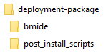

BMIDE folder contains the latest BMIDE template to deploy.

post_install_scripts folder contains the scripts and post install instructions for both server side and client side (RAC and AWC)

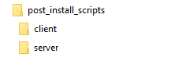

Server folder includes the following folders:

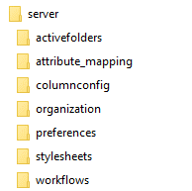

# Deployment Instructions

Unzip the supplied zip file. Once the supplied package has been unzipped you should see the following structure:

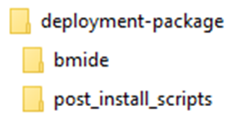

## BMIDE Deployment

### Deploy BMIDE Package

1. Stop all Services.
   * Make sure all users are all users logged out of Teamcenter, Active Workspace.
   * Stop pool manager services.
   * Stop webserver (e.g. j-boss/apache)
   * Stop Dispatcher services (Scheduler, Modular, Dispatcher Client)
   * Stop Indexer services.
   * **Make sure Microservices ( TC Process Manager) and FMS ( Teamcenter FSC ) Services are up and Running**
2. Start Teamcenter Environment Manager (**TEM**). In the **Maintenance** panel, choose **Configuration Manager** and click Next.

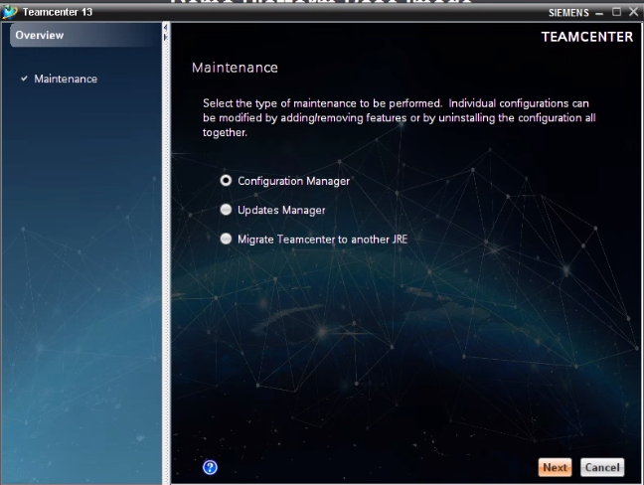

1. In the **Configuration Maintenance** panel, choose **Perform maintenance on an existing configuration** and click **Next**.

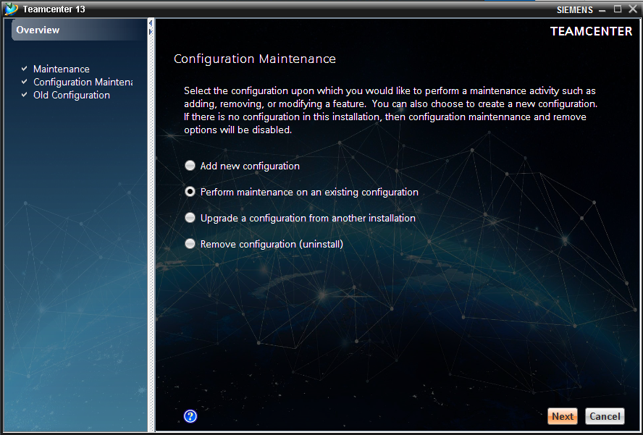

1. In the **Old Configuration** panel, select the configuration from which the corporate server was installed and click **Next**.

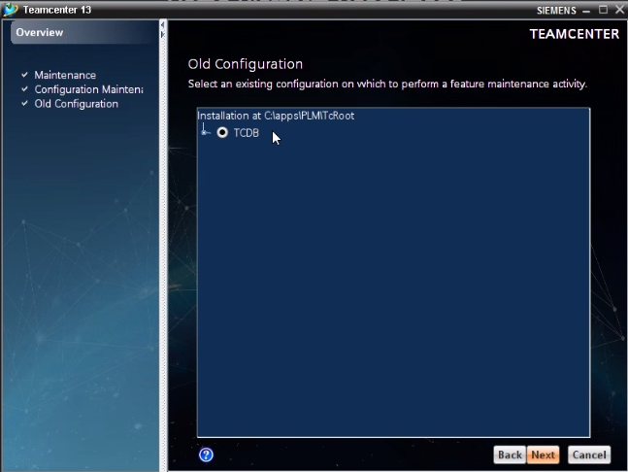

1. In the **Feature Maintenance** panel, If it is first time then you will use “Add/Remove Features to Add Sierra Space RIMTC Solution. If this solution is installed already then go to next screen

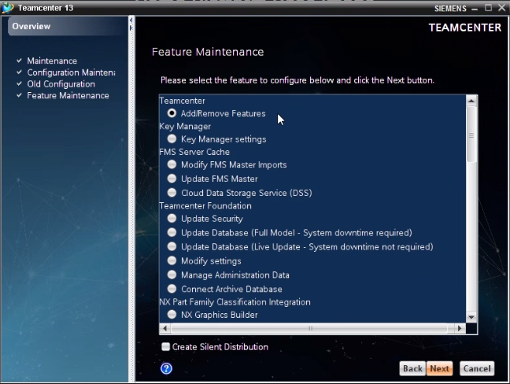

1. Browse for the RIMTC solution in the

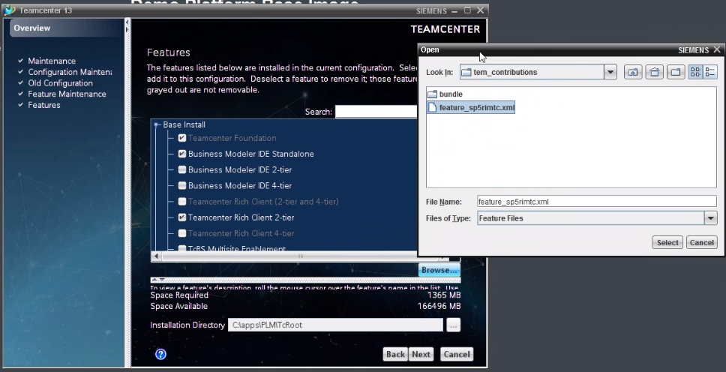

1. Choose Feature RIMTC

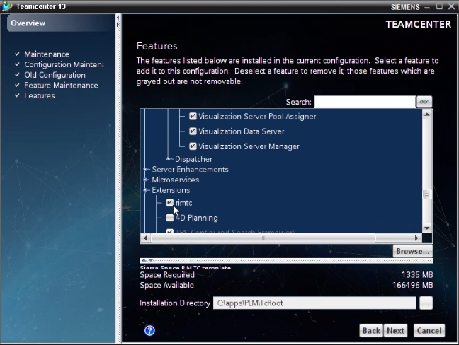

1. Click Next. Choose OK in the Warning Message that comes up. Ii just reiterates that microservices & FMS services should be UP and rest of TC Services services stopped

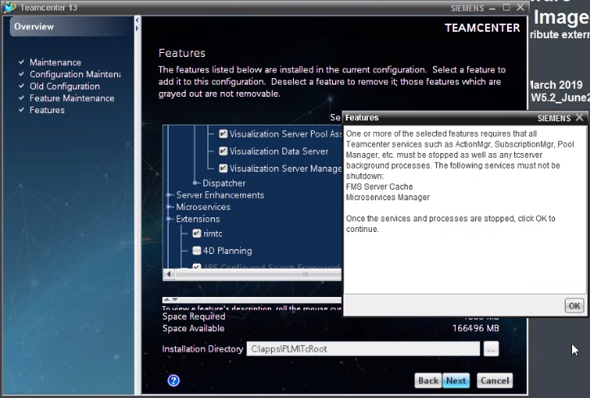

1. If you have already isntalled the feature and coming from Maintainenace , then you will reach to this screen instead of Step 5. In the **Feature Maintenance** panel, under the Teamcenter Foundation section, select Update Database (Full Model – System downtime required) Features and click Next. For

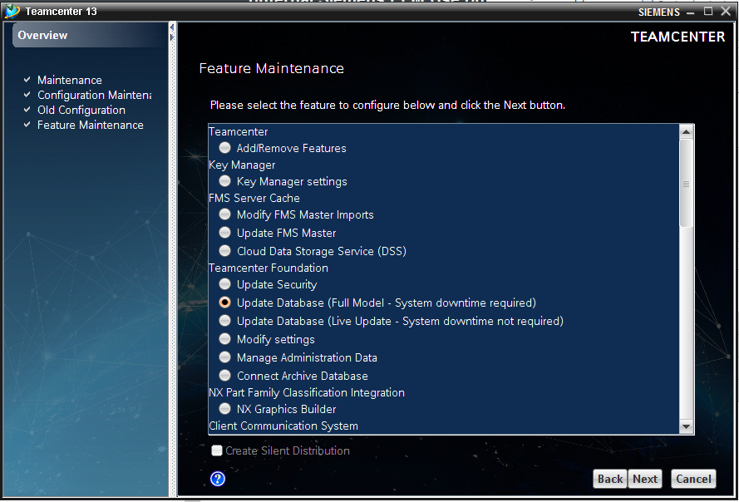

1. In the Media Verification window, click Next to continue.

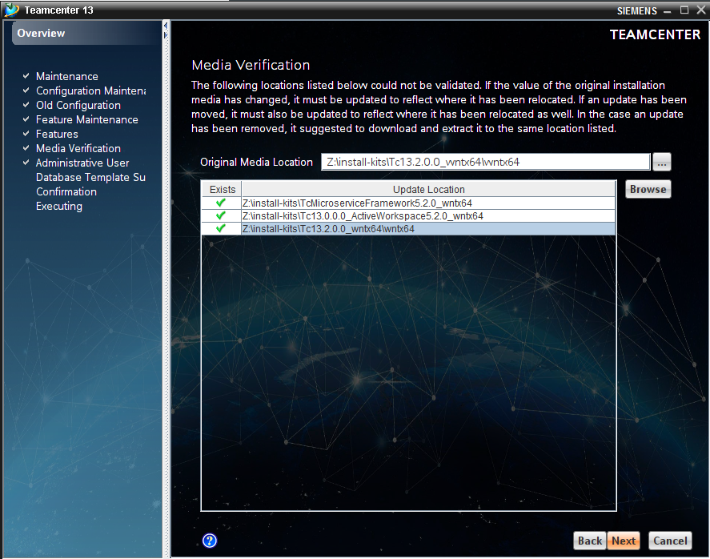

1. In the **Teamcenter Administrative** User panel, enter your username and password (In this case **infodba)** to log on to the server, and click **Next**

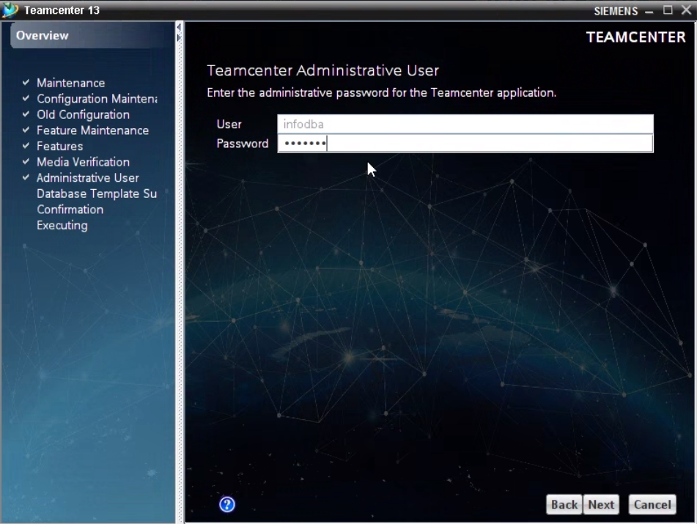

1. The **Update Database (Full Model)** panel displays the list of templates that are installed as part of your template install. Click **Browse**

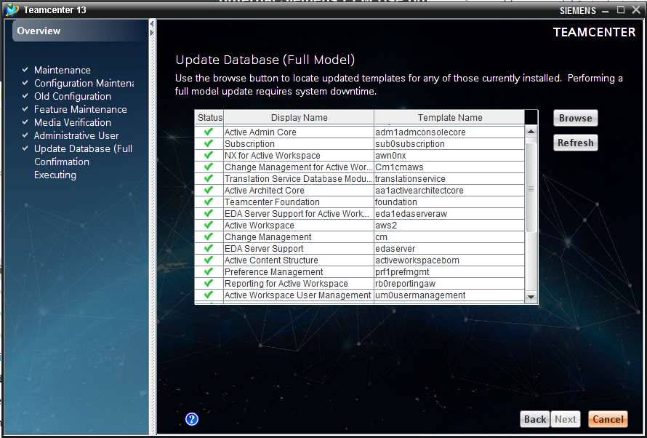

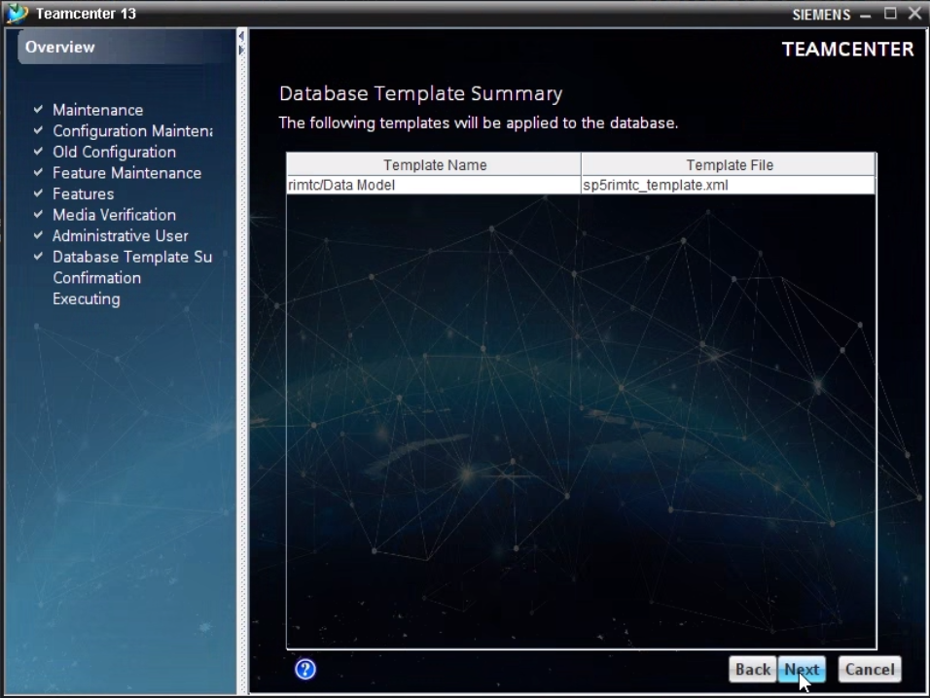

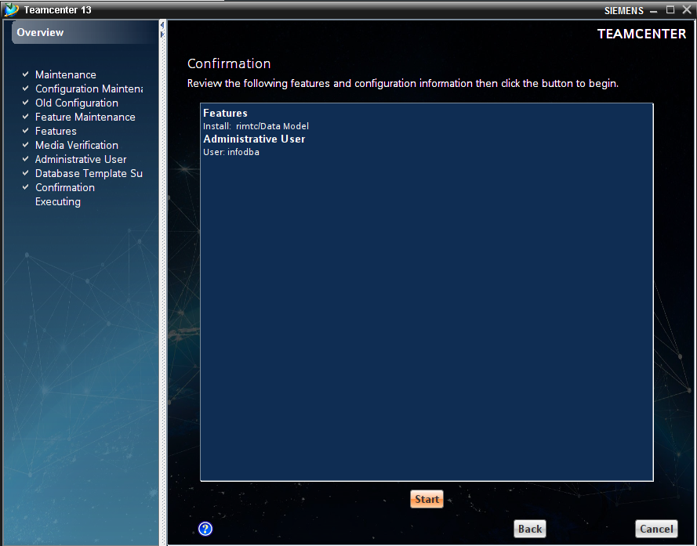

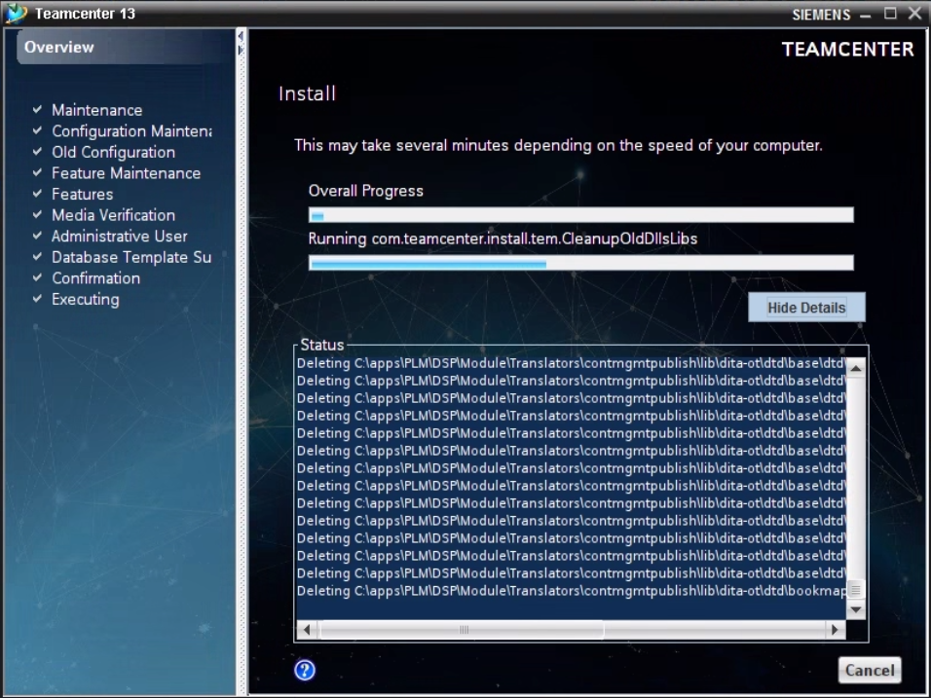

1. In the Open dialog window, locate the Teamcenter Rapid Implementation BMIDE Project in BMIDE\ sp5rimtc_wntx64_XXXXXXX. Click Open to select the BMIDE project. Click Next to continue.
   * For example: BMIDE\sp5rimtc_wntx64_1.0_2022_01_24_15-22-20

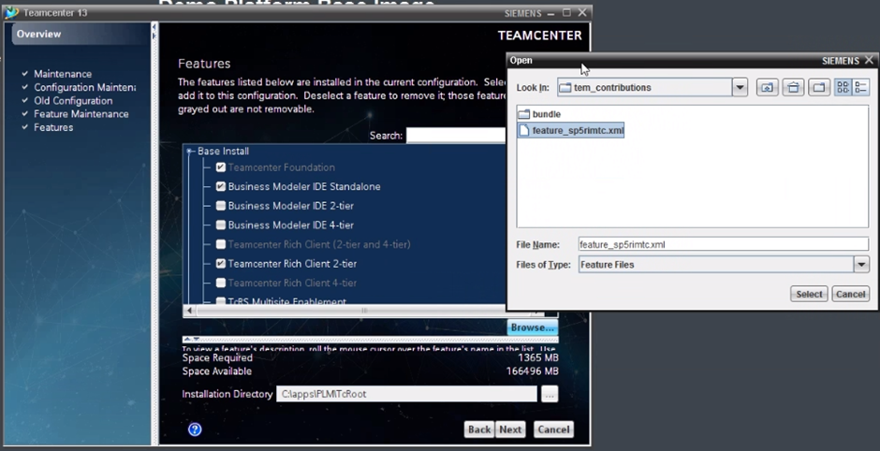

1. In the **Confirmation** panel, click **Start** to begin the installation.

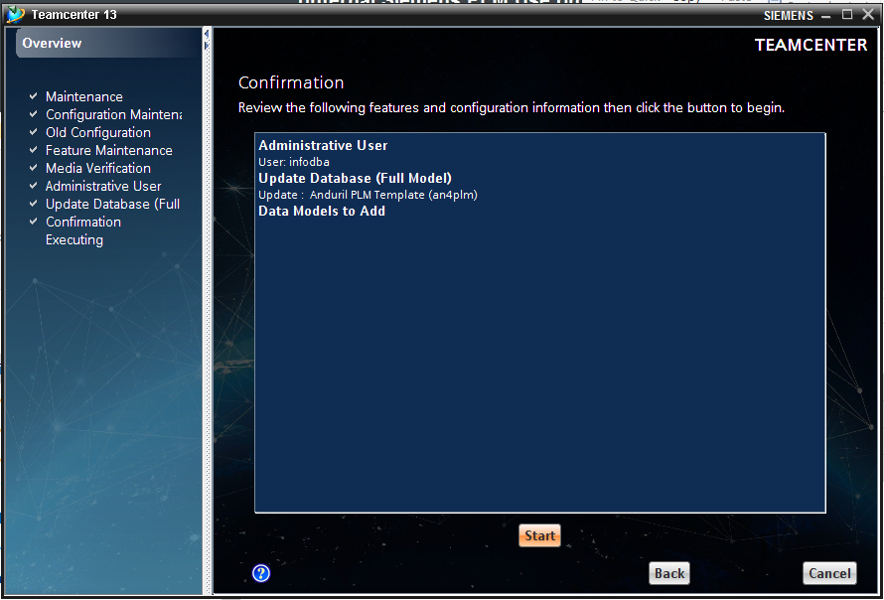

1. After a successful deployment, TEM will provide a success message. Close TEM.

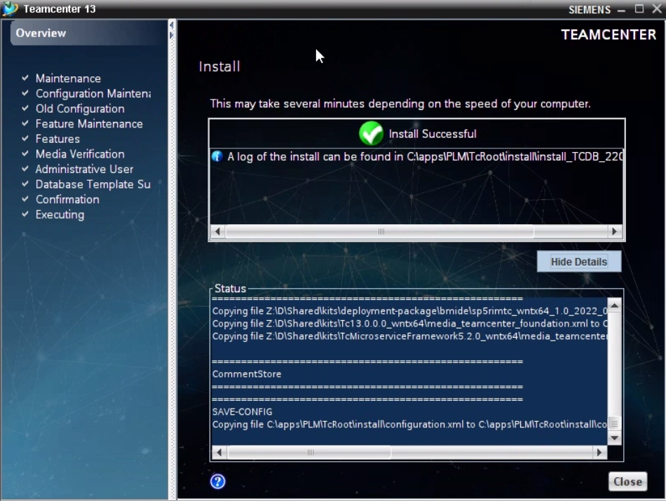

## Server-Side Post Deployment Steps

Set the Credentials

1. Open a Teamcenter command window
2. Change directory to post_install_scriptsl\Server folder

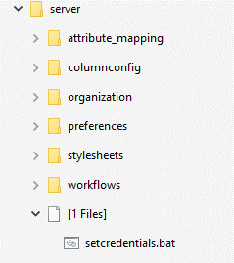

1. Update **setcredentials.bat** file for your env and run the batch file.
2. All of the following batch files needs to be executed from a Teamcenter command window (by running **setcredentials.bat** file)

### Import Organization

1. Change directory to Post_install_scripts\server\organization folder

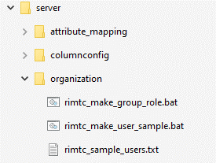

1. In the Teamcenter command prompt, execute the following commands in the above-mentioned order:

|  |
| --- |
| *rimtc_make_group_role.bat*  *rimtc_make_user.bat* |

NOTE: FOR DEV Environments you have rimtc_make_user_sample.bat for creating Sample users. For Test. QA and Prod you will have rimtc_make_user.bat and actual user lists

*l*

1. In the command prompt, verify the organization imported without errors

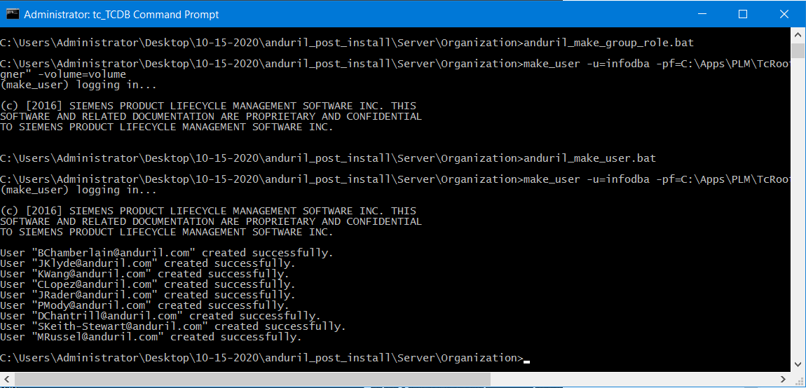

### Import Preferences

1. Change directory to Post_install_scripts\server\preferences folder

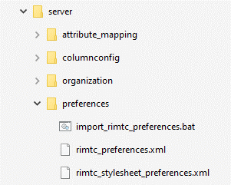

1. In the Teamcenter command prompt, execute the following commands in the above-mentioned order:

|  |
| --- |
| *import_rimtc_preferences.bat* |

1. In the command prompt, verify the preferences imported without errors

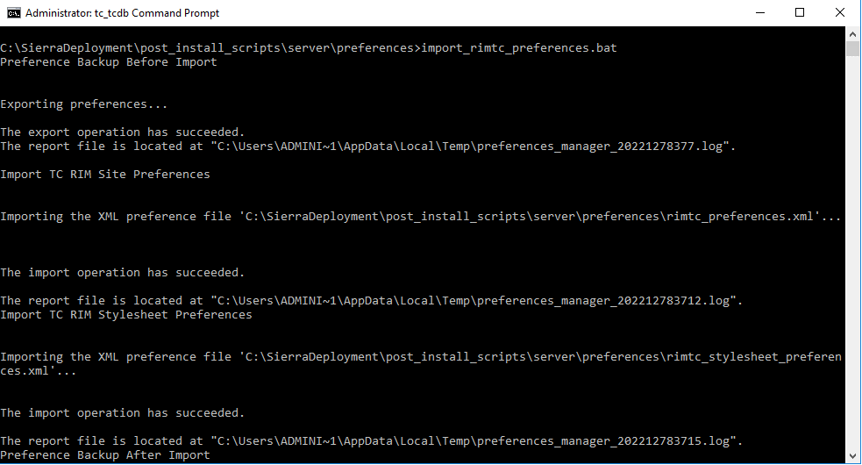

### Import Stylesheets

1. Change directory to Post_install_scripts\Server\ Stylesheets folder

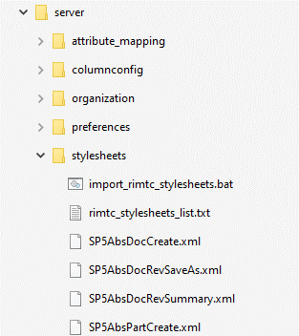

1. In the Teamcenter command prompt, execute the following commands in the above-mentioned order:

|  |
| --- |
| *import_rimtc_stylesheets.bat* |

1. In the command prompt, verify the stylesheets imported without errors

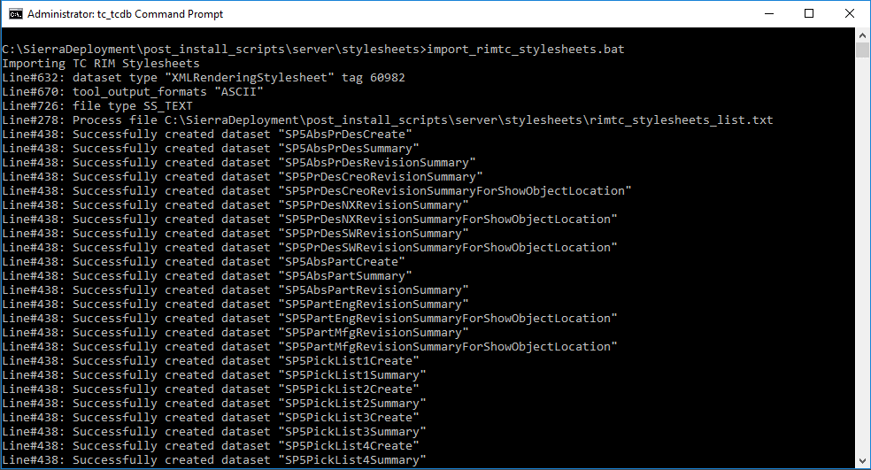

### Import Workflows

1. Change directory to the Post_install_scripts\Server\ Workflows folder
2. Follow steps described in Instructions.txt file to replace “ProgressionPath.plmxml” in the %TC_DATA% folder.
3. In the Teamcenter command prompt, execute the following commands in the above-mentioned order:

|  |
| --- |
| *import_rimtc_workflows.bat* |

1. In the command prompt, verify the Workflows imported without errors: 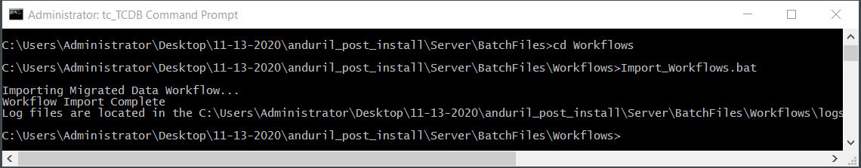

### Import Column Configuration

1. Change directory to the Post_install_scripts\Server\ Columns folder

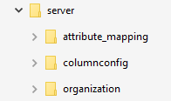

1. In the Teamcenter command prompt, execute the following commands in the above-mentioned order:

|  |
| --- |
| *import_rimtc_column_config.bat* |

1. In the command prompt, verify the column configuration files imported without errors

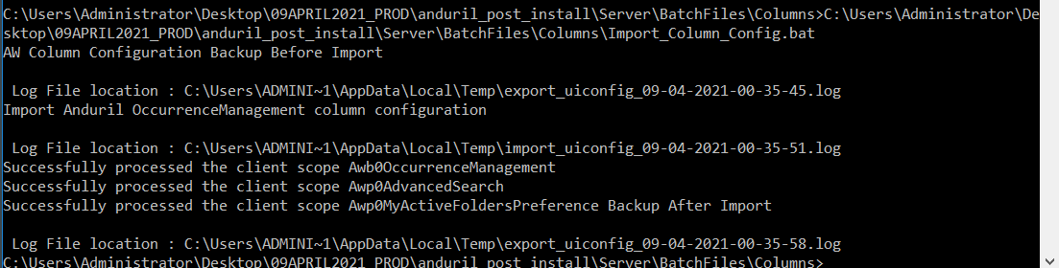

### Attribute Mappings

1. Change directory to the post_install_scripts\server\attribute_mapping folder
2. Select and copy the tc13_nx_attr_mappings.txt file

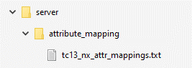

1. Paste the tc13_nx_attr_mappings.txt file in %TC_ROOT%\bin folder
2. In the Teamcenter command prompt, change directory to %TC_ROOT%\bin and enter the following commands:

|  |
| --- |
| *import_attr_mappings.exe -u=infodba -p=infodba -file=tc13_attr_mappings.txt* |

1. In the command prompt, verify the attribute mappings imported without errors

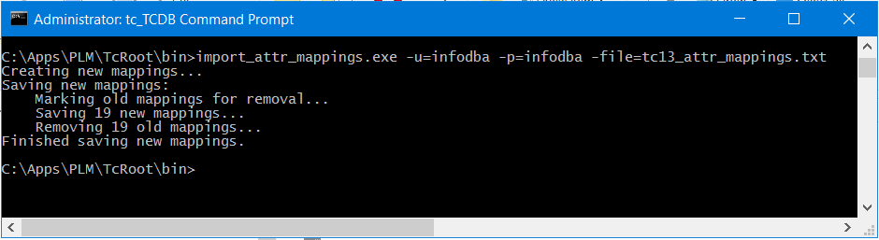

## Client-Side Post Deployment Steps

### Install Active Workspace Icons for Teamcenter Rapid Implementation Items

1. Open a Windows explorer and locate the **aws2** folder. It is generally under %TC_ROOT%\aws2
2. Make sure you have a back up of the existing aws2 folder
3. Navigate to Post_install_scripts\Client \icons-aw folder

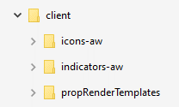

1. Copy the icons (*.svg) files from “**Post_install_scripts\Client\icons”** folder to “**%TC_ROOT%\ aws2\stage\src\image”** folder
2. Open Teamcenter command prompt with admin user
3. Change directory to **%TC_ROOT%\aws2\stage** folder
4. Execute following commands. **NOTE: IF YOU ARE GOING TO DO STATUS FLAGS ANDVISUAL INDICATORS TEHN DO NOT EXECCUTED IT NOW , DO IT AFTER Sec 4.3.3**

|  |
| --- |
| *initenv.cmd*  *awbuild.cmd* |

1. Verify the command run successfully and AWC client is rebuilt.

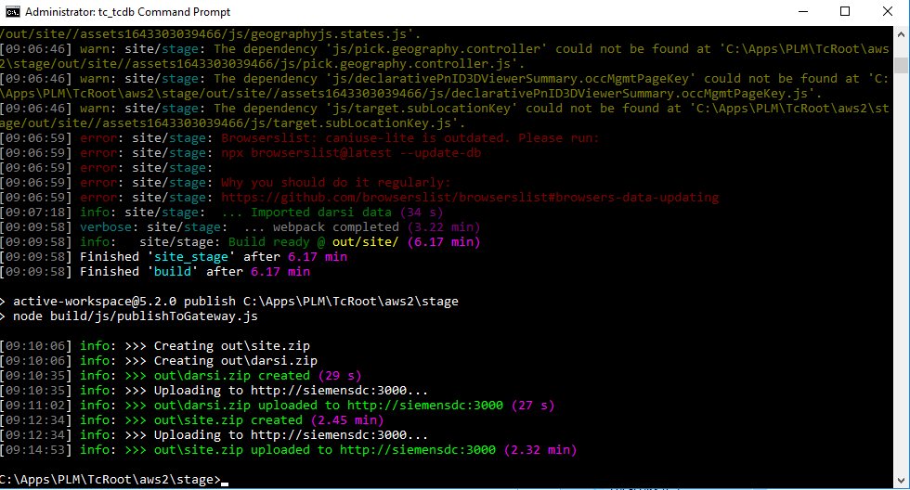

### Install Active Workspace Icons for Status Flags

1. Open a Windows explorer and locate the propRenderTemplates folder. It is generally under %TC_ROOT%\aws2\stage\repo\tc-aw-framework\src_native\assets\propRenderTemplates
2. Navigate to Post_install_scripts\Client\AWC\propRenderTemplates folder

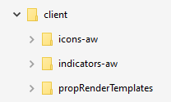

1. Copy the files generateReleaseStatus.js and releaseStatusRenderer.html from “**Post_install_scripts\Client\propRenderTemplates”** folder to “**%TC_ROOT%\ aws2\stage\repo\tc-aw-framework\src_native\assets\propRenderTemplates”** folder
2. Open Teamcenter command prompt with admin user
3. Change directory to **%TC_ROOT%\aws2\stage** folder.
4. Go to next Section for Visual Indicators

### Install Visual Indicators for Release Status

1. Copy “**Post_install_scripts\Client\AWC\** **indicators-aw \** **s5indicatormodule”** folder to “**%TC_ROOT%\ aws2\stage\src\”** folder



1. Backup “**%TC_ROOT%\ aws2\stage\src\solution\ kit.json** file
2. Open kit.json from “**%TC_ROOT%\ aws2\stage\src\”**
3. Add the module “**s5indicatormodule**” under the list of modules in kit.json as shown below

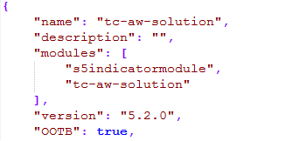

1. Open Teamcenter command prompt with admin user
2. Change directory to **%TC_ROOT%\aws2\stage** folder
3. Execute following commands.

|  |
| --- |
| *initenv.cmd*  *awbuild.cmd* |

1. Verify the command run successfully and AWC client is rebuilt.

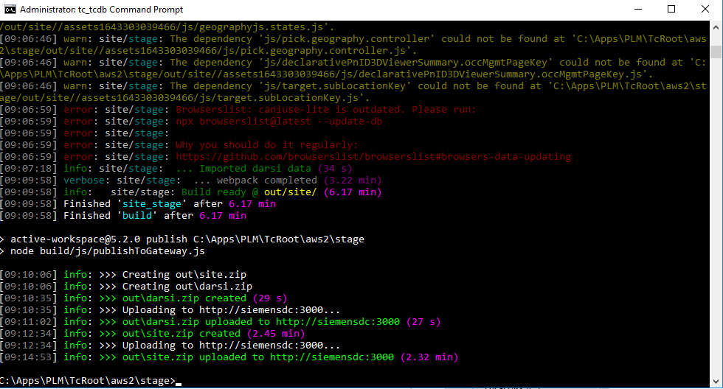

## NX integration Steps

1. Preference file Load will Create/update a Tc preference **TC_NX_Foreign_Datasets** with the following value:

DatasetType="DirectModel" NamedReference="JTPART" NamedReferenceFormat="BINARY" NamedReferenceTemplate="jt

1. Add the following NX Customer defaults value

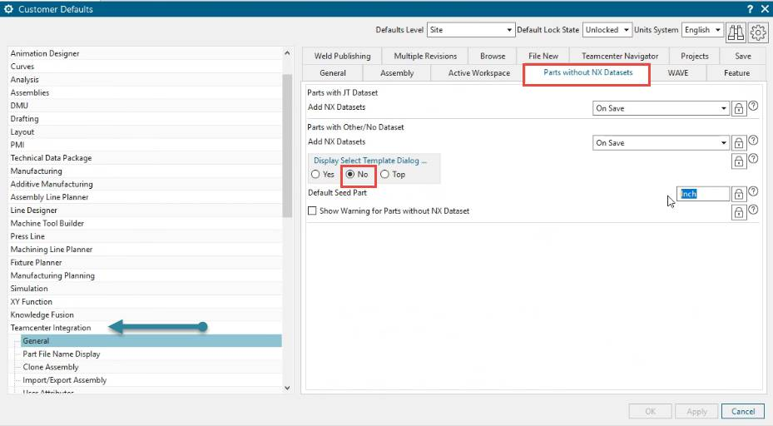

## Restart Services

1. Restart Tc web tier and services.

## AWC Indexing

Execute the following commands to update the Solr Schema File

1. Open a Command prompt from tc_menu with Tc variables set
2. Go to %TC_ROOT%/bin
3. Run

bmide_modeltool.bat -u=infodba -p=infodba -g=dba -tool=all -mode=upgrade -target_dir="%TC_DATA%"

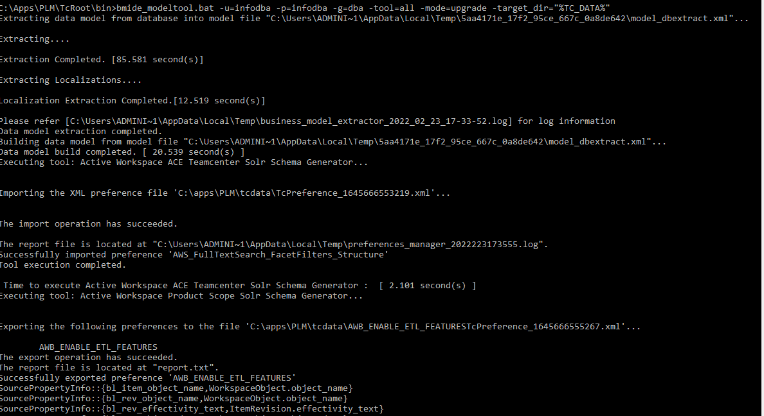

1. Go to SOLR HOME, It could be at %TC_ROOT%\solr-8.6.3 . Run

TcSchemaToSolrSchemaTransform.bat %TC_DATA%\ftsi\solr_schema_files

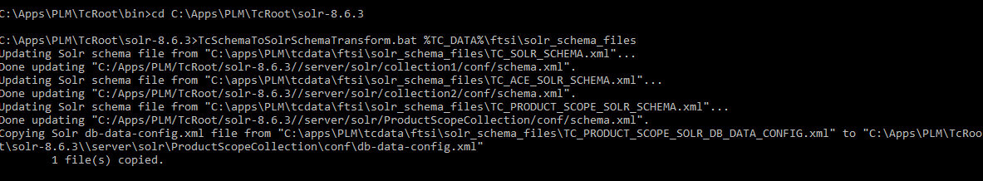

1. Restart Solr and Indexing services using following commands
   1. cd %TC_ROOT%\TcFTSIndexer\bin
   2. runTcFTSIndexer.bat -task=objdata:sync

Post data model deployment validate the preference “AW_FullTextSearch_TypeCategories”. The custom BO information will be added

# Appendix A: Checklist

|  |  |  |
| --- | --- | --- |
| **SN** | **Task** | **Location in deployment document** |
| 1 | Install Teamcenter Server Extensions | Section 2.2.1 |
| 2 | Deploy BMIDE Package | Section 4.1.1 |
| 3 | Import organization | Section 4.2.1 |
| 4 | Import Preferences | Section 4.2.2 |
| 5 | Import Stylesheets | Section 4.2.3 |
| 6 | Import AWC Column Config | Section 4.2.5 |
| 7 | Import Workflows | Section 4.2.4 |
| 8 | Install AW icons and indicators | Section 4.3.1, 2, 3 |
| 9 | Restart Services | Section 4.5 |
| 10 | Run Solr Indexing | xxx |

# Appendix B – TEM : Teamcenter and AWC Options

Add TEM Screenshots

